**Mid-semester test**

严禁抄袭，查重出现相同／相似内容超过50字，计0分

题目基本按照难度递增的顺序，请根据自己的情况酌情取舍。

1. How could the resting membrane potential be produced and maintained? What is the role of intracellular sodium ions in maintaining the resting membrane potential and how to demonstrate your answer experimentally?

**Product and Maintain**: Working of ion transporters on plasm membrane construct concentrate gradient of each ions. When cells are resting, the membrane is mainly permeable to K+ ions and K+ is tend to reach its equilibrium potential. Therefore, flow and change of distribution of K+ ions produced resting membrane potential. And the Na+-K+ pump can construct the K+ concentration gradient to maintain resting membrane potential.

**Intracellular sodium influences the activity of Na+-K+ pump** [1] which play an important role to maintain resting potential. When the intracellular sodium concentration decreases, the activity of Na+-K+ pump also decreases. Therefore, the membrane potential cannot be well maintained.

**Demonstration:** We can use patch clamp to determine Na+- K+ pump activity in different sodium concentration conditions. First, fill two electrodes with normal intracellular fluid and intracellular fluid removed sodium, respectively. Then use these electrodes to do outside-out recording to single Na+-K+ pump in the normal extracellular condition. We can observe that the activity of Na+-K+ pump in the intracellular fluid without Na+ is lower than which in the normal intracellular fluid. Base on this phenomenon, we can speculate that low sodium concentration makes it harder to maintain resting potential.

1. Action potential in giant axons is resulted from opening of voltage-dependent K+ and Na+ channels, respectively. How action potential could rise and then decay since both Na+ and K+ channels show very similar voltage dependent curves? Prove your points with the patch clamp method.

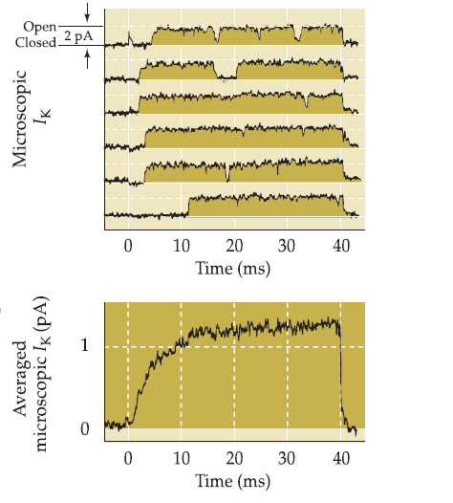**a.** Treat giant axon by tetrodotoxin to block voltage-gated Na+ channels. Then give depolarization pulse to an area with single voltage-gated K+ channel. Use patch clamp to record the current of single channel (Fig. 1). We can observe there is a delay before K+ current but the channel remains open during the depolarization.

**Figure 1**

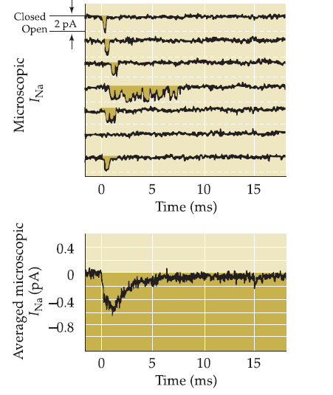**b.** Treat giant axon by Cs+ to block voltage-gated K+ channels. Then give depolarization pulse to an area with single Na+ channel. Use patch clamp to record the current of single Na+ channel. (Fig. 2). We can observe that there is no delay before Na+ current but the current cannot remain as long time as K+ current. Therefore, this properties of two kinds of channel reveal that the delay of K+ channels give Na+ channel an opportunity to change the membrane potential and construct the rising phase of the action potential. Na+ current attenuates rapidly, whereas K+ current become the main current which construct the falling phase of the action potential.

**Figure 2**

1. (1) Design two experiments to demonstrate influx of Ca2+ in the presynaptic terminals is necessary and sufficient in triggering neurotransmitter release.

(2) Design one experiment to show that presynaptic depolarization is not required for transmitter release.

**(1)** **Necessary**:

**a.** Use Ca2+ channel blocker to treat a squid giant presynaptic terminal to remove the increasing of Ca2+ concentration and use water to treat another.

**b.** Give stimuli to both giant nerves.

**c.** We can only determine potential change on the postsynaptic membrane whose presynaptic terminal was treated by water.

**Sufficient**:

**a.** Inject Ca2+ solution into a squid giant presynaptic terminal and saline solution (without Ca2+) into another.

**b.** We can determine potential change on the postsynaptic membrane whose presynaptic terminal was injected Ca2+.

**(2)** We can design 4 groups of squid giant presynaptic terminals, all of whom are treated by Ca2+ channel blocker.

Group1: Inject saline solution (without Ca2+). Clamp membrane potential to -70mV.

Group2: Inject Ca2+ solution. Clamp membrane potential to -70mV.

Group3: Inject saline solution. Clamp membrane potential to 20mV.

Group4: Inject Ca2+ solution. Clamp membrane potential to 20mV.

|  |  |  |  |  |
| --- | --- | --- | --- | --- |
| Group | 1 | 2 | 3 | 4 |
| Injection | saline solution (without Ca2+) | Ca2+ solution | saline solution (without Ca2+) | Ca2+ solution |
| Membrane potential clamped by voltage clamp. | -70mv | -70mv | 20mv | 20mv |
| Presence of Postsynaptic membrane potential change | No | Yes | No | No |

This result indicates that presynaptic depolarization is nether necessary nor sufficient for transmitter release.

1. Listing criteria for neurotransmitter. Naming two conventional neurotransmitters. Naming two unconventional neurotransmitters.

**Criteria of Neurotransmitter:**

(1) Presynaptic neuron can synthesis neurotransmitters and contains neurotransmitters.

(2) Neurotransmitters are storage in presynaptic vesicles, and they can be released into synaptic cleft when presynaptic terminal is stimulated. The release must be Ca2+ dependent.

(3) Neurotransmitters can specifically interact with receptors on postsynaptic membrane to trigger downstream physiological effects.

(4) Neurotransmitters can be inactivated by enzymes or other ways.

**Conventional neurotransmitters**: Acetylcholine, norepinephrine.

**Unconventional neurotransmitters**: NO, endocannabinoid.

1. Does nicotinic Ach receptor have an equilibrium potential? Why?

No, it doesn’t. Nicotinic Ach receptor is permeable to multiple cations. When the net current is zero, the potential reaches its reversal potential but the potential is not equilibrium potential for all kinds of ions. Therefore, this reversal potential of nicotinic receptor is not the equilibrium potential and its impossible for multiple ions reach a coincident equilibrium potential.

1. Describe the key transduction pathways in the retinal rods/cones: receptors, G proteins, key enzymes, second messengers, and channels.

(1) The absorption of photon triggers the configuration change of 11-cis-retinal which will convert to all-trans-retinal. And this change induces the conformation change of **rhodopsin**.

(2) The change of **rhodopsin** induces the activation of **transducin, a kind of G protein.**

(3) **Transducin** interact with **PDE** and make it be active.

(4) **PDE** degrade **cGMP** to GMP inducing the decreasing of **cGMP** concentration.

(5) For the decreasing of **cGMP** concentration, the **cGMP sensitive channels**, which is permeable to Na+ ions, will close.

(6) The closure of channels induces hyperpolarize of the membrane potential which involve downstream signal transduction.

1. Describe the key circuits from the sensory organ to the cortex for the visual, and auditory systems.

**Visual system:**

Retinal ganglion cells (RGCs) receive stimuli from retina sensory cells. RGCs from temporal area retina project to ipsilateral dorsal lateral geniculate nuclei (LGNs), whereas RGCs from nasal retina project to contralateral LGNs. Projection neurons from LGNs project to primary visual cortex to relay visual information.

**Auditory system:**

Spiral ganglion axons mostly (95%) terminate on inner hair cells and receive stimuli from them. Whereas spiral ganglion neuron is bipolar, another axon of each spiral ganglion neuron terminated in the dorsal and ventral cochlea nuclei in brainstem. Neurons in dorsal nuclei directly project to contralateral interior colliculus in the midbrain or via intermediate neurons in the lateral lemniscus. Neurons in ventral nuclei project to ipsilateral and contralateral superior olivary nuclei which integrate auditory from both left and right ears. Also, there are neurons in superior olivary nuclei project to interior colliculus, the important center of auditory. Interior colliculi are connected to medial geniculate nuclei of the thalamus by projection neurons. Finally, medial geniculate nuclei relay information to temporal lobe of cerebral cortex. (Fig. 3)

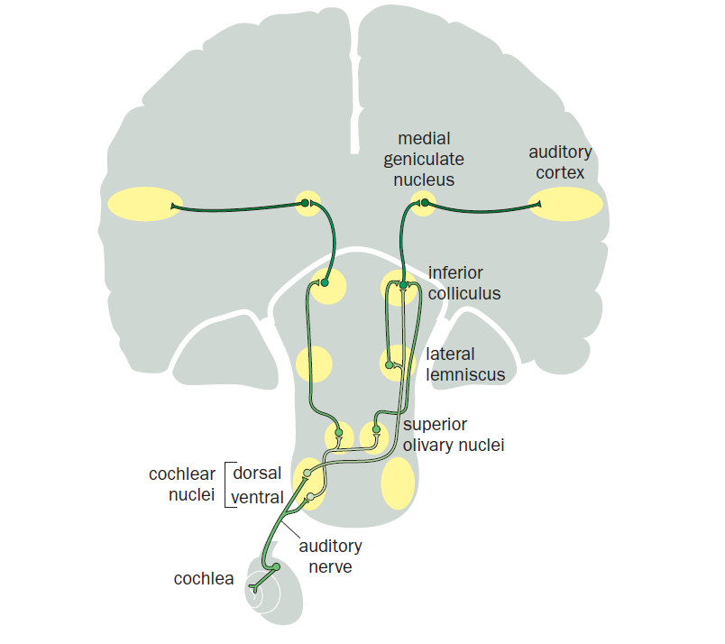

**Figure 3**

1. Define the terms “receptive field” and “cortical column”. How are receptive fields different for a ganglion cell vs a neuron at layer 4 of V1? Can the concept of receptive field be applied to the auditory system?

Receptive field: The space span which can sense stimuli and influence the activity of a neuron is the receptive field of this neuron.

Cortical column: Cortical column is a group of neurons in brain cortex which contain approximately same receptive field.

(1) Receptive field characteristic of V1 is more integrative than those in RGCs.

(2) They mainly encode information of lines and edges.

(3) There are two types of cell called simple cell and complex cell in V1. The receptive field of simple cell is converged from a series of LGN cells; hence the receptive field of complex cell is converged from a series of simple cells.

The concept of receptive field can be applied to the auditory system to describe the space or spectrotemporal span of sound can induce auditory.

[1] Vassalle M. Contribution of the Na+/K+-pump to the membrane potential.[J].Experientia.,1987,43:1135-1140.

Fig. 1 and Fig. 2 Neuroscience 5 edition

Fig. 3 Principles of Neurology